5 CLASSY ELEGANT VALENTINE’S DINNER OUTFITS FOR EVERY VIBE

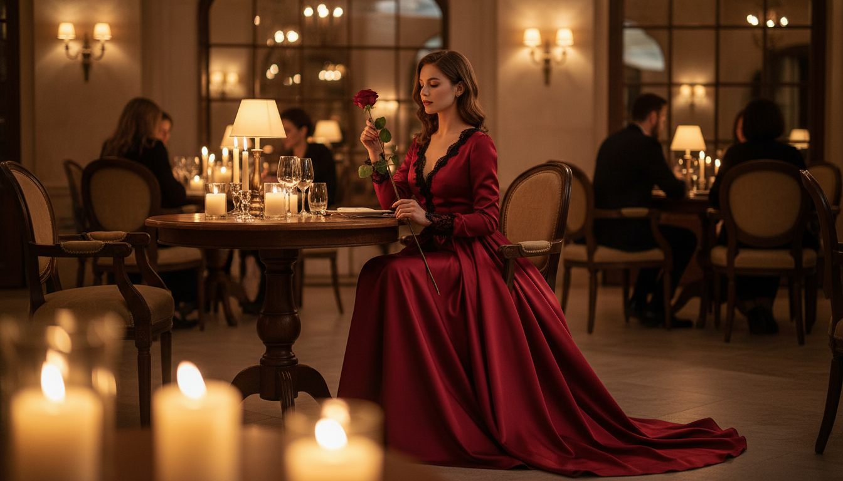

Valentine's Day is almost here and you need a look that screams chic. Finding the right look for a fancy night out can feel like a lot of pressure. You want to look polished but also feel like yourself while eating good food. These 5 Classy Elegant Valentine’s Dinner Outfits for Every Vibe will help you pick the best look for your specific plans. We are talking about soft fabrics and shapes that make you feel amazing. No matter if you are going to a five star restaurant or a cozy wine bar, your style should be top tier. Check out these gorgeous looks for your romantic night out and get ready to turn heads. Save your favorite styles to your mood board.

# Red Satin Slip Dress

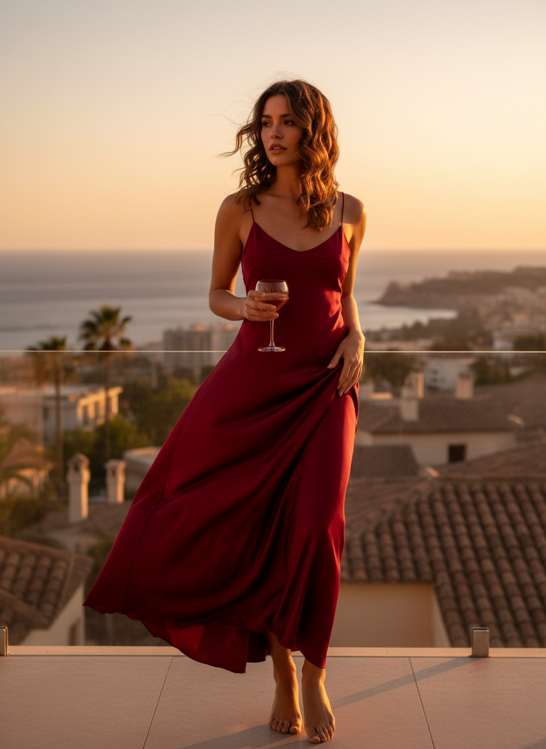

A red satin slip dress is the ultimate choice for a romantic evening. The fabric flows perfectly and gives off a soft glow under dim restaurant lights. You can pair it with some gold jewelry and thin heels for a very polished look. This is a staple for any 5 Classy Elegant Valentine’s Dinner Outfits for Every Vibe list because it never goes out of style.

# Velvet Blazer and Trousers



Try a velvet blazer and trousers if you want a powerful vibe. This outfit feels very expensive and keeps you warm during the chilly February air. It is a great alternative to a dress while still looking very high end. Pick a dark color like emerald green or deep burgundy to keep the mood festive. This set looks amazing with a simple pointed toe boot or a sleek heel. It is one of the most comfortable 5 Classy Elegant Valentine’s Dinner Outfits for Every Vibe.

# Off the Shoulder Midi

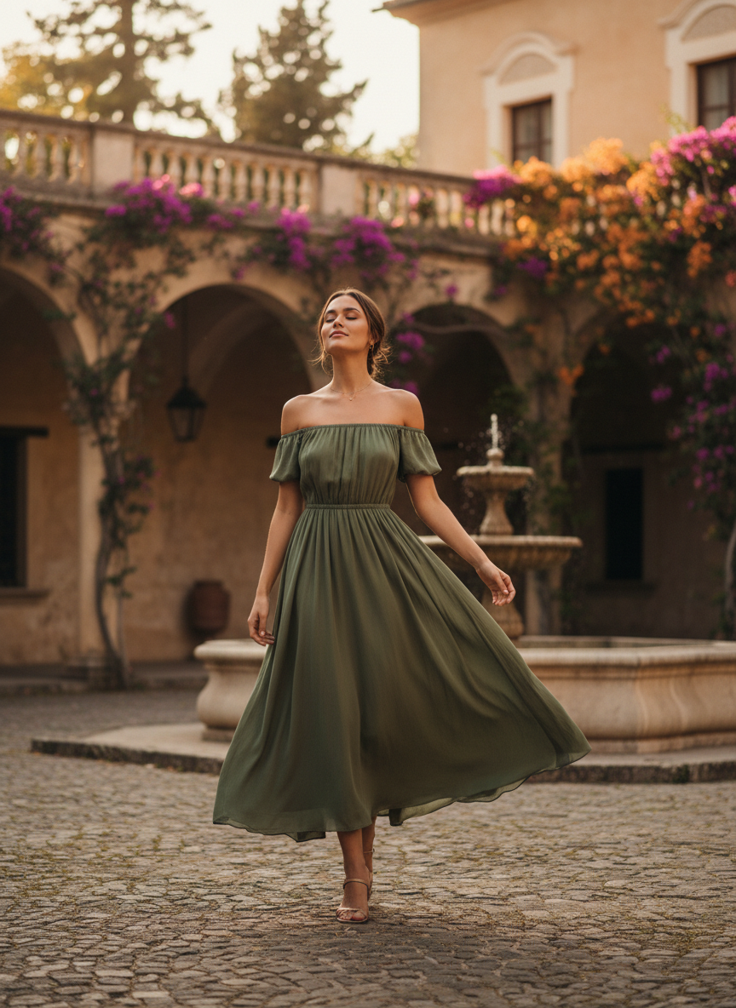

An off the shoulder midi dress shows just enough skin while staying very tasteful. This style is perfect for a long dinner where you want to feel pretty and feminine. The length keeps it modest and sophisticated for any upscale venue. It fits the 5 Classy Elegant Valentine’s Dinner Outfits for Every Vibe theme perfectly because it is so romantic.

# Black Lace Long Sleeve Dress

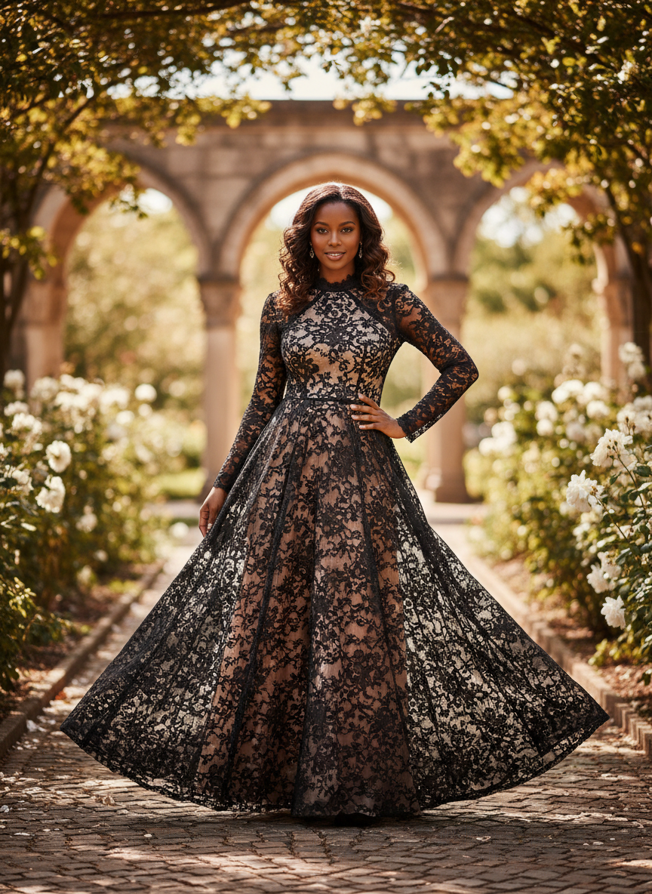

A black lace long sleeve dress is a timeless pick for a night out. The lace details add a lot of texture and visual interest without being too loud. It is a very mysterious and chic way to dress up for your date night. Match this with a small clutch and simple earrings to let the lace be the star of the show. You will feel so confident in this dark and romantic aesthetic. This is a top pick for 5 Classy Elegant Valentine’s Dinner Outfits for Every Vibe lovers.

# Champagne Silk Skirt and Cashmere Sweater



A champagne silk skirt and cashmere sweater combo is the peak of quiet luxury. This look is very cozy but still looks like you put in a lot of effort. It works so well for a more relaxed but still very fancy dinner spot. These 5 Classy Elegant Valentine’s Dinner Outfits for Every Vibe are meant to make you shine.

# Conclusion

These outfits are perfect for making your night feel extra special. You deserve to feel beautiful and confident while you celebrate love. Pick the look that fits your energy best and have the best time. Pin these looks to your style board now.